Unit 4: “Probability and Statistics” Vocabulary List

Sample:
Section of a whole group
To get data from part of a group and use it to give information about a whole group.

Random Sample:
A section of a whole group that was selected through chance

Example of a random sample: Asking every 5th student who enters

Sampling Bias:
When particular population is more likely to be chosen.

Example:
You are taking a survey on opinions of grocery stores. You stand outside Wegmans and survey every 10th person. This is bias, because even though you are randomly selecting a person they are likely to say that they prefer Wegmans since they are currently shopping there!!

Inferences:
A judgement or conclusion.

Drawing a mathematical Inference:
To look at the data and draw conclusions based on the information.

Population:
Whole set of individuals, items or data for which a statistical sample is drawn

Example:
In my study of who will win the next presidential election, the population are all of the US citizens
Statistics:
The study of how to collect, organize, analyze, and interpret data
Simulation:
Numerical modeling of a real-world situation

Example:
Using a program on a computer that “rolls a die”

Mean Absolute Deviation:
The average distance between each data value and
the mean.

To calculate:
1. Find the mean.

2. Find the distance between each data value and the mean. That is, find the absolute value of the difference between each data value and the mean.

3. Find the average of those differences
Probability:
The chance that a particular outcome will occur
Probabilities are between 0 and 1 (no chance it will happen/definitely will happen)

Probability = $\frac{\# of favorable outcomes}{\# of possible outcomes}$

Tree Diagrams:
A way of showing all possible outcomes
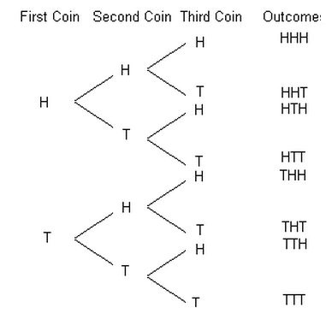

Example of a Simple Event: Tossing a die

Compound Event:
Two or more simple events.

Example of a Compound Event: Tossing a coin 3 times.
----or----
Rolling a die, then tossing a die

